Lesson 1 Demo 1: Setting up a Kubernetes Cluster

This section will guide you to:

* Set up a kubernetes cluster with one master and two worker nodes

This lab has one sub-section, namely:

1. Setting up the kubernetes cluster

**Step** **1**: Setting up the kubernetes cluster

* You have a cluster with a master and two worker nodes already set up in the Kubernetes admin lab by default
* On the **master** and **worker1** and **worker2** nodes run the below command:

*sudo kubeadm reset*

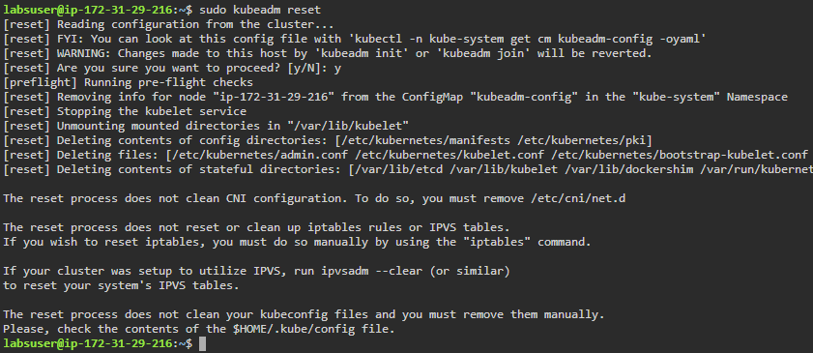

* To initialize the cluster run the following command on master only.

*sudo kubeadm init*

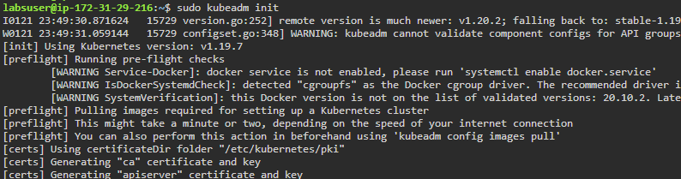

* To start using your cluster, you need to run the following on master:

*mkdir -p $HOME/.kube*

*sudo cp -i /etc/kubernetes/admin.conf $HOME/.kube/config*

(Type **‘y’** when asked to overwrite)

*sudo chown $(id -u):$(id -g) $HOME/.kube/config*

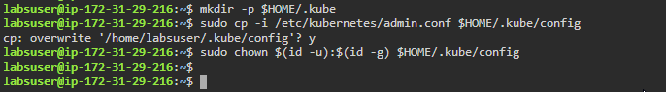

*sudo kubectl get nodes*



**Note:** You should now see a single node **master** deployed.

* Copy the **kubeadm join command** that you can see on the screen of your master node (This appears after running **sudo kubeadm init** command)

**Note**: **kubeadm join** command runs with a unique token.

* Run the **kubeadm join** command as a root user on each of the **worker1** and **worker2** nodes

**Note**: This is only a sample kubeadm join command

*sudo kubeadm join 172.31.25.37:6443 --token fmeegy.veyfwhprxyrzgecl *

*--discovery-token-ca-cert-hash *

*sha256:abbbb0e9cad2d51cdb606e9adfdc0acb6e81d26d82603eefded9370df28f8517*

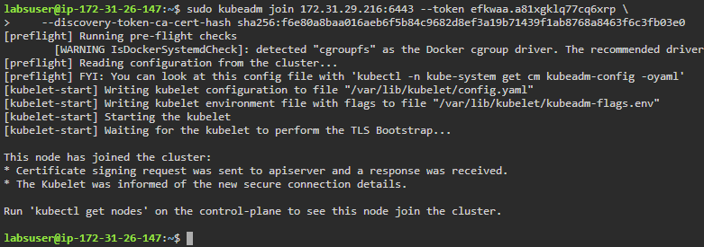

**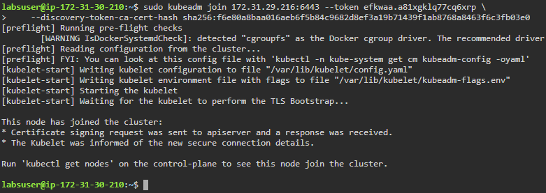  
Note:** In case you need to find your unique token, run the command **sudo kubeadm token create --print-join-command**

* On the **master node,** run the following command to install the weavenet plugin in order to create a network:

*kubectl apply -f "https://cloud.weave.works/k8s/net?k8s-version=$(kubectl version | base64 |tr -d '\n')"*

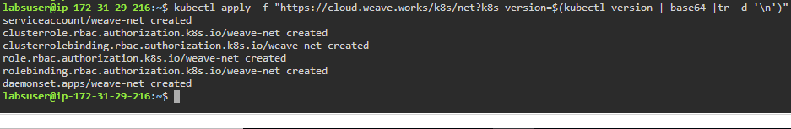

* List all the nodes again to check the **Status** of nodes

*kubectl get nodes*

